NVS
Neurological Vocational Services
Harborview Medical Center

Box 359744 ~ 325 Ninth Avenue ▪ Seattle, Washington, USA 98104 ▪ Telephone: 206-744-9130 ▪ Fax: 206-744-9988

Dear Supporter:

We truly hope that you will be able to join us at the 15th Annual NVS Spring Gala Brunch and Auction scheduled for Sunday, May 19 (12.30 to 4.30 PM) at the spectacular Columbia Tower Club. This is always a great event, with entertainment, supportive celebrities, great auction items, and wonderful food and beverages. It is also our one major fundraiser of the year. We could not, for instance, afford our client job coaching staff without the funds raised through our Spring Gala. This year your help is particularly needed as we are serving clients with increasingly complex and challenging conditions. So why attend? . . .

- It’s a worthy cause and a great value!
- Enjoy live music
- Jeff Stokes, Entertaining Auctioneer.
- Great auction items!
- Fabulous brunch and wine selection!
- Enjoy enlightening presentations from
our medical guests and clients receiving awards

Here’s how . . . Simply fill out the registration form below and send it back to us with your personal check, or go to our website nvsrehab.org/springgala.htm . Please purchase your Early Bird reservations by April 30th . We’re counting on your support to assist us in fulfilling our mission of “Helping people with neurological conditions gain independence, one person, one job, at a time.”

Warm regards,

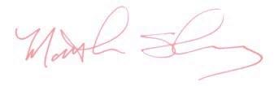
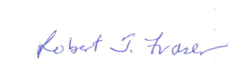

Robert T. Fraser, Ph.D., CRC Matt Storey
Executive Director, President,
Neurological Vocational Services, Neurological Vocational Services,

Additional auction items, as well as personal and corporate donations, are always welcome!
Please call (206) 744.9130 – Thank you!

Name of Guest(s):

Name:
Address:

Daytime Phone: ( ) - Guest E-mail:
E-mail:

Early Bird (purchase by April 30}
@ $85 @ $160
Singles: Couples: = Total Number of Registrations*: Check Amount: $
(*One Couple counts as 1 registration.)
After May 1st
@ $95 @ $185
Singles: Couples: = Total Number of Registrations*: Check Amount: $

(*One Couple counts as 1 registration.)

